# C3- S7 PRACTICE

# Ex 1: Can I go to PNC?

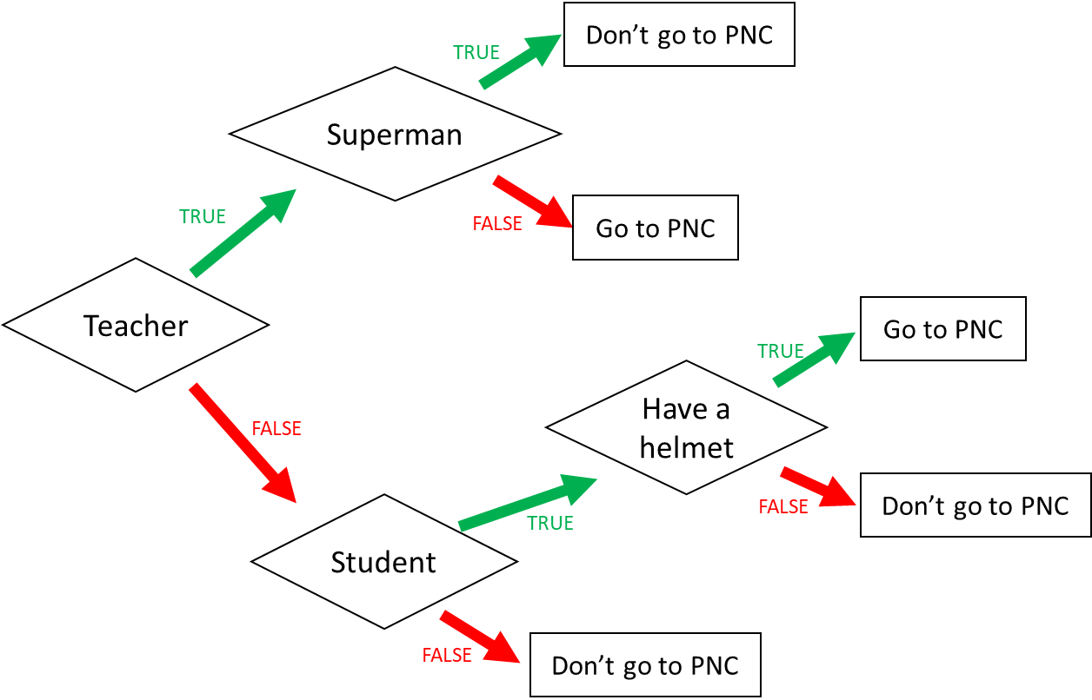

1. I am a teacher and I am superman, can I go to PNC?No

1. I am not a teacher and not a student, can I go to PNC?No
2. When can I go to PNC? (Express the condition using a Boolean expression)

I go to PNC if:

Answer: (teacher and i’m not superman) and (i’m not teacher and student and have a helment )

Ex 2: What do I eat?

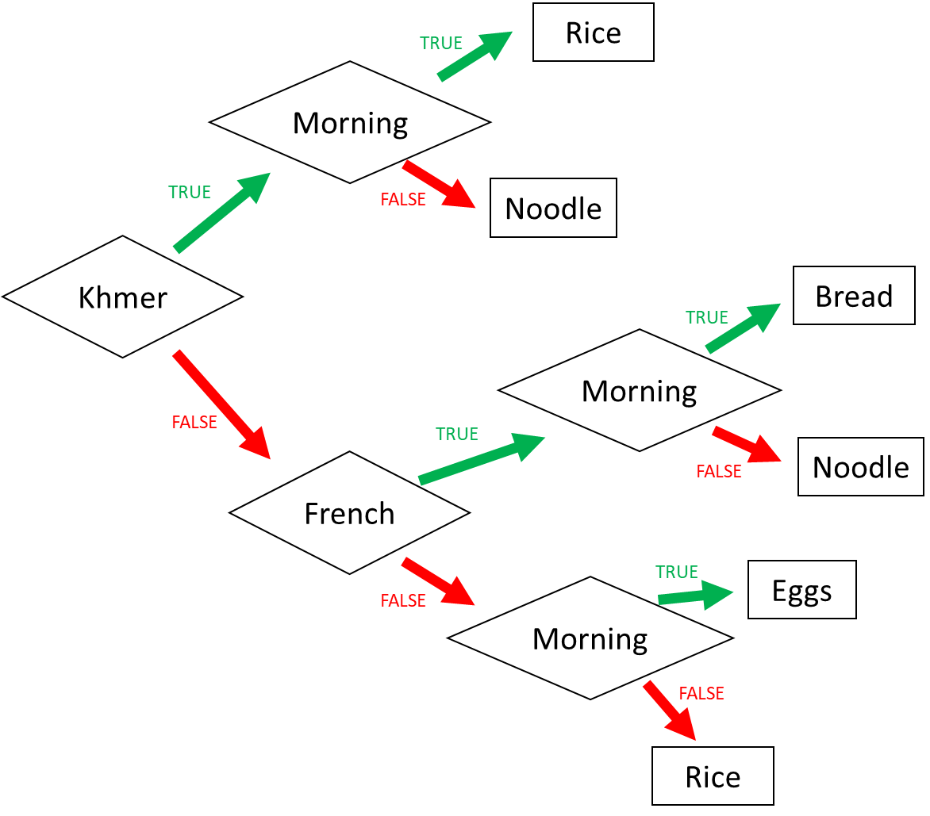

1. I am Khmer and it is the evening. What do I eat? I can eat Noodle

2. I am French and it is the morning. What do I eat?I can eat Bread

3. I am American and it is the morning. What do I eat? I can eat Egg

4. When do I eat rice? (Express the condition using a Boolean expression)

I eat rice if:

Answer: I can eat=(Khmer and morning) or (i’m not Khmer and I’m not french and not Morning ) and (khmer and french and morning)

Answer: khmer and i’m not morning) or ( i’m not khmer and french and i’m not morning) or (i’m not khmer and i’m not french and i’m not morning)

Ex 3: Do I go to the pool?

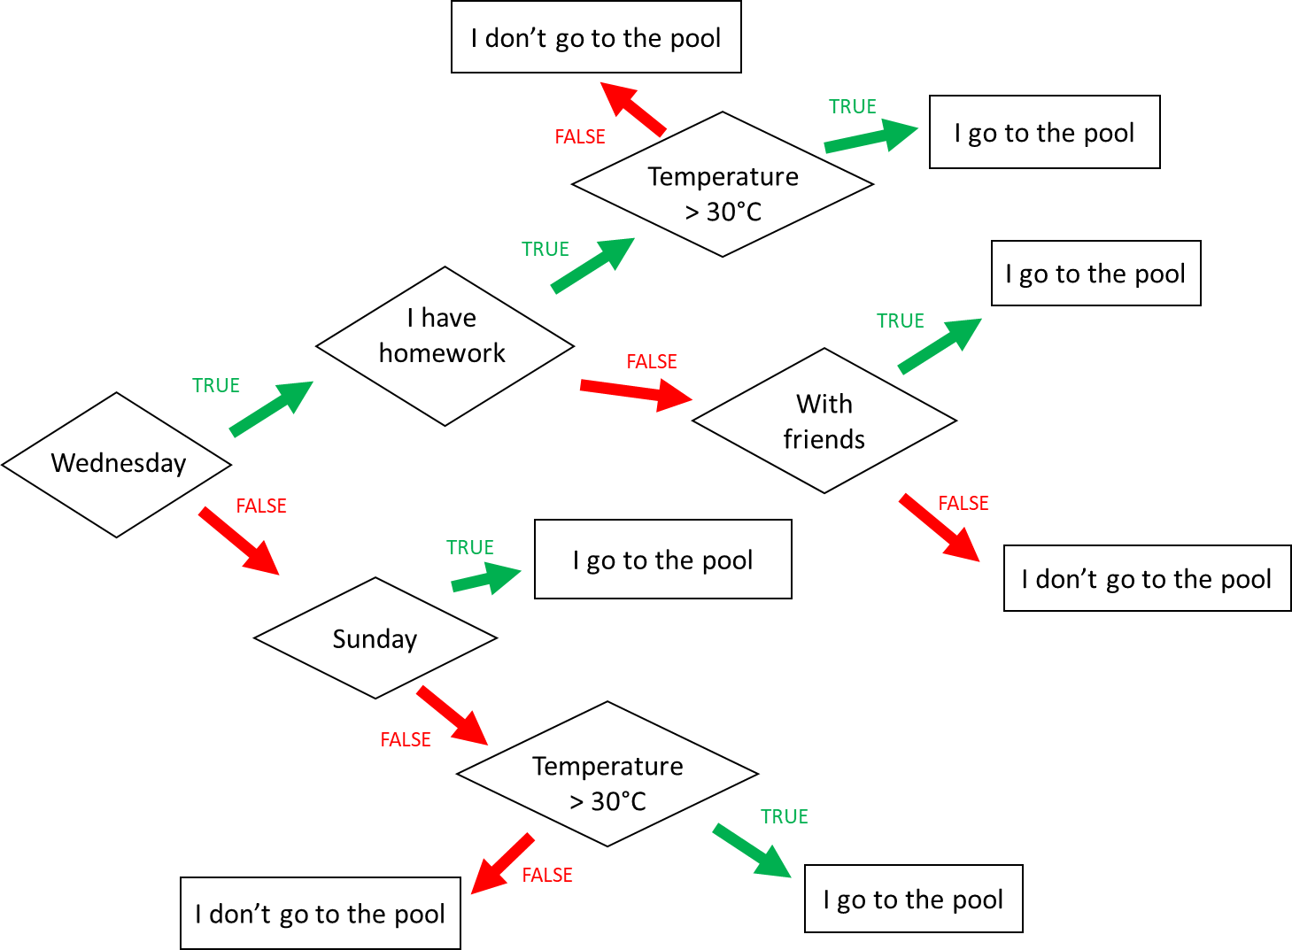

**Input 1 :**

* Wednesday
* Temperature = 31°C
* **Homework**

🡪 Do I go to the pool ? Yes

**Input 2 :**

* Monday
* Temperature = 35°C
* I have no friend

🡪 Do I go to the pool ? No

**Input 3 :**

* Wednesday
* I have **no** homework
* I’m with friends
* Temperature = 28°C

🡪 Do I go to the pool ? No

When do I go to the pool ? (Express the condition using a Boolean expression)

I go to the pool if:(Wednesday and i have homework and Temperature>31 C) or ( Wednesday and i’m not have homwork and with friends) or (i’m not Wednesday and Sunday) or (i’m not Wednesday and i’m not Sunday and Temperature> 30 C)

I don’t go to the pool:( Wednesday and i have homwrok and i’m not Temperatur> 30C) or ( Wednesday and I’m not have homework and i’m not wite friends) or ( i’m not Wednesday and i’m not Sunday and i’m not Temperature)

Ex4: Do I create a Facebook account?

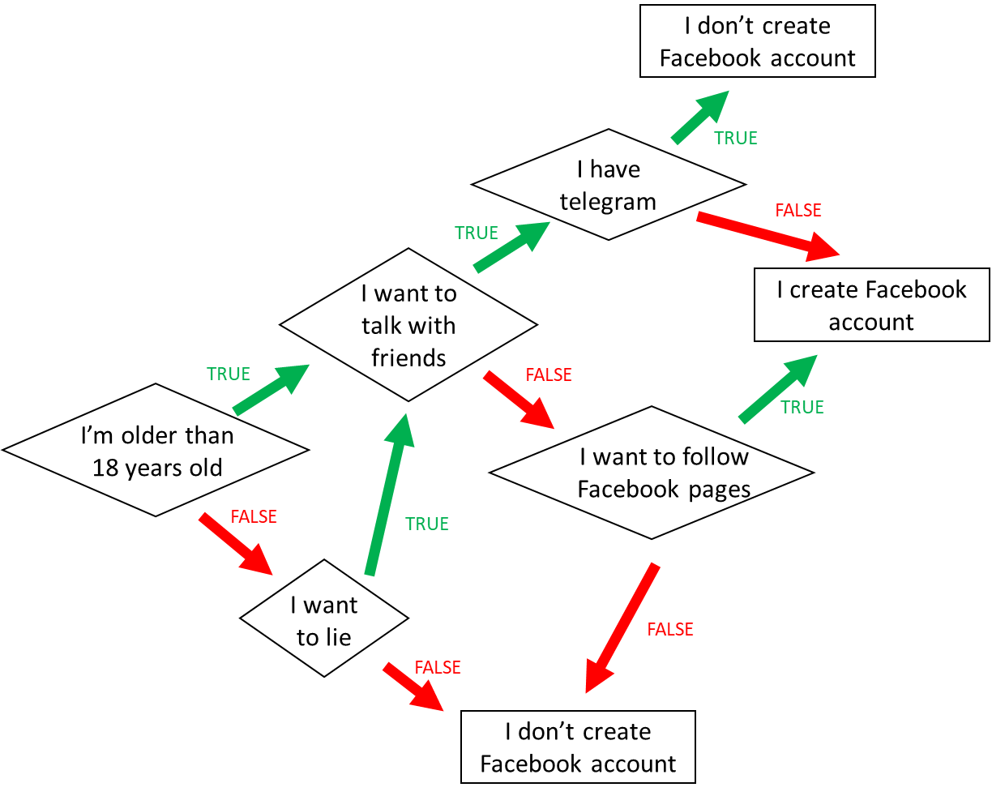

1. When do I create a Facebook account? (*Express the condition using a Boolean expression)*

Answer:( I’m older than 18 years old and I want to talk with friend and i’m not have telegram) or ( I’m older than 18 years old and i’m not want to talk with frieds and i’m want to follow facbook pags) or (i’m not older than 18 years old and I want to lie and i’m not want to talk with friends and i’m not older than and I want to lie and I want to talk with friends and I’m not have telegram)

1. When **don’t I** create a Facebook account? *(Express the condition using a Boolean expression)*

*Answer: (* I’m older than 18 years old and I want to talk with friends and I have telegram) or (*(* I’m older than 18 years old and

Ex5: Create the chart flow

**Q1** Complete the char flow to follow those rules:

* If I am a girl and it is sunny, I wear a skirt
* If I am a girl and it is not sunny, I wear jeans
* If I am a boy and it is sunny, I wear a short
* If I am a boy and it is not sunny, I wear jeans

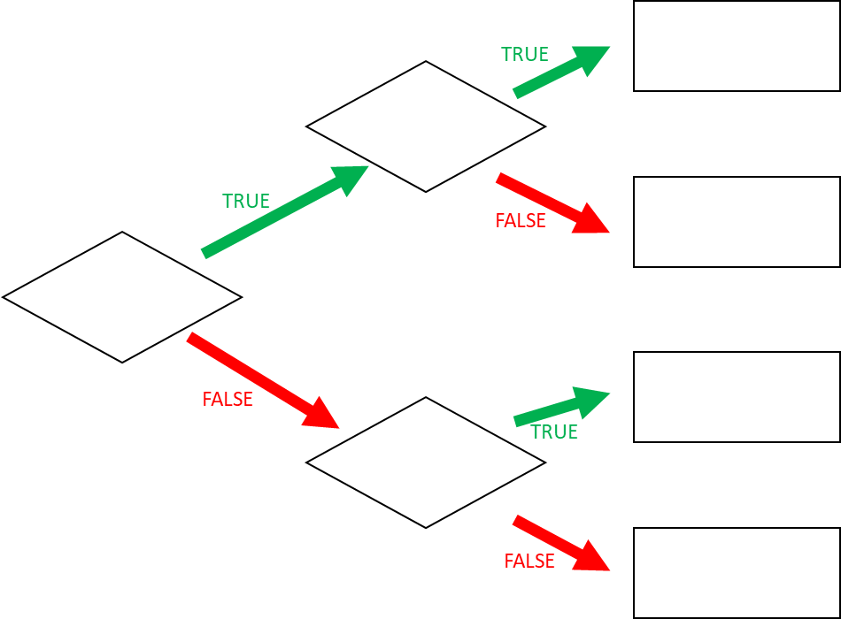

I wear a skirt

Sunny

Girl

**Q1** When do I wear jeans? *(Express the condition using a Boolean expression)*